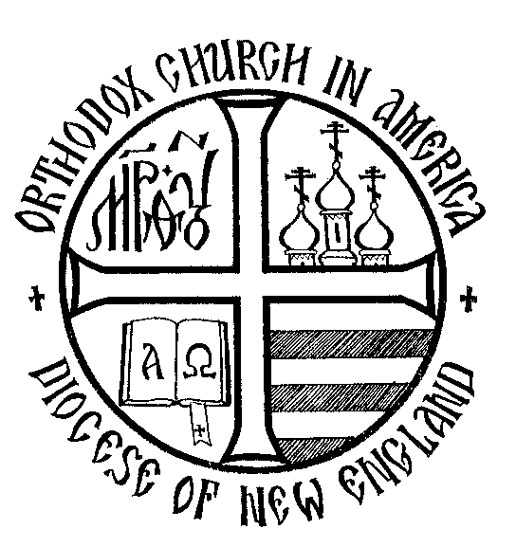
Diocese of New England
Orthodox Church in America

2014
Parish Grant Application

Parish Grant Application

Parishes in good standing in the Diocese of New England may use this form to apply for a 2014 Diocesan Parish Grant. See the companion document Background Information on Grant Applications located on the diocesan website that explains the grant initiatives’ goals, applicant qualifications, and the grant process.

Parish Grant Initiative

Diocese of New England - Orthodox Church in America

Parish Grant Application

Applicant Information

Information on Parish Applying for the Grant
Parish Name
Note
Before filling out this application please do the following:
- Read the document: Background Information for Applicants is located on Diocesan Website,
- Contact Deacon Paul Nimchek by email at nimchekpaul@sbcglobal.net or by phone at 860-489-3220 with questions and to give an “early declaration” of your intent to deliver a grant application.
Parish Address
City State Zip Code
Parish Website address
Are you teaming with another parish/church/institution?
Yes No (If no skip the next section.)

Information on a Partner Parish
If desired, a parish can partner with other parishes or churches (Orthodox or not) or local institutions in that can provide additional resources or necessary skills or facilities.
Parish/church/organization name
Address
City State Zip Code
Denomination
If the partner is an Orthodox parish indicate jurisdiction (OCA, Antiochian etc.)

Contacts

Priest
Priest Name Priest Phone Priest Email

Project Leader
Information about the layperson that will be the project leader and primary contact. The lay leader should be from the primary (not partner) parish. (Some projects may require that priest be the leader.)
Name Address
Daytime Phone Evening phone Email address

Grant Project Information

Description of Project for Which You Are Seeking a Grant

Need
Describe the need you are trying to address. How will this ministry enliven your parish? Does this effort shore up a perceived weakness of your parish? Is it a particular strength?

Objectives
Describe the key objectives of the project. Measurable objectives are desirable-- but sometimes impossible.

Description
Provide a description of your project. What is this effort/project about and what will you do? Reminder: Grant projects must demonstrate effort (time and /or talent) on the part of parishioners. Describe how your parish will be involved. How many will be involved (will 2-3 people or many be involved)?

Project Category
Which category(s) best describe the area(s) of parish life that will be impacted by your project? Check all that apply.

Campus Outreach
Charitable Outreach
Communication
Education
Evangelization
Fellowship
Leadership
Stewardship Development (financial or other)
Worship
Youth
Other (describe).
Describe
Please do not submit projects that deal with facilities upgrades/ improvements.

Steps/Plan/Probability of Effective Execution
What are the primary steps associated with executing this effort? Make this only as complicated as it needs to be and no more. We simply want an indication that you have thought this through.

- (Continue in this box if more steps are necessary.)

Ability to Execute
Those evaluating your grant request will want to understand if you can do what you propose and do it effectively? Use the box below to describe your ability to do what you propose. Do you have appropriate skill and experience? Have you talked with others with useful background? Can you offer a track record of executing efforts of similar scope?

Costs
List the costs associated with this grant request.

Item/Cost category | $ Amount
 | $
 | $
 | $
 | $
 | $
Total | $
Anything else to say about costs?

Grant Amount Request
Indicate the total $ amount you are requesting. Target grant size is $1500 – $2500. Do not request more than $2,500 – because you’re unlikely to receive that much.
We are requesting $ .

Impact
Use this section to describe the impact this project could have on your parish and/or the local community (neighborhood). Indicate the potential timeframes in which results might be realized or when the project outcomes can be assessed.

To Your Parish
Describe how you hope this effort will positively impact the life of your parish. This is required.

How soon might you see these outcomes/impact? How do you propose evaluating these outcomes?

To Your Community/Neighborhood (Outside of your Parish)
This is optional. It is hoped that many projects will look outside the parish to bring the light of Christ to your community. Internally focused projects, however, are perfectly acceptable.
Describe how you hope this effort will positively impact the neighborhood or community.

How soon might you see these outcomes? How would they be evaluated?

To Other Parishes in the Diocese
This is also optional. It is hoped, however, that many projects can provide benefit to other parishes through the sharing of lessons learned and an understanding of what worked and did not work.

How soon might you see these outcomes? Evaluation?

Commitment of Best Efforts
Our statements on this application are truthful. If our parish receives a grant we will use our best efforts to execute the project as described and we will be good stewards of these grant funds. We will provide interim reports to the Diocese, as requested, on our progress so that others may learn from our efforts.
, Priest (Type name – we will consider it a signature)
, Lay Project Leader (Type name – we will consider it a signature)

Deadline
- Applications will be accepted until August 1, 2014
- Applications will be evaluated and grants awarded upon receipt
- Submit this application electronically (via email) to Deacon Paul Nimchek at nimchekpaul@sbcglobal.net
- IF YOU DO NOT RECEIVE A CONFIRMATION from Deacon Paul, contact him by email or by phone at 860-489-3220.
IT IS YOUR RESPONSIBILITY TO BE SURE THE APPLICATION IS RECEIVED.

For information contact any member of the 2014 Grant Program Administrative Committee:
- Deacon Paul Nimchek - nimchekpaul@sbcglobal.net
- Fr. Robert Dick - rfd2@earthlink.net
- Matushka Cindy Voytovich - voytcindy@earthlink.net

